2303A51581
BATCH-10
LAB ASSIGNMENT-2.3
Task 1: Word Frequency from Text File
#PROMPT
Generate Python code to read a text file and count the frequency of each word. The code should handle case insensitivity and remove punctuation.
Also explain how the code works step by step.
#CODE
def word_frequency(file_path):
freq = {}

with open(file_path, "r", encoding="utf-8") as file:
for line in file:
words = line.lower().split()
for word in words:
word = word.strip(".,!?;:\"()[]{}")
freq[word] = freq.get(word, 0) + 1

return freq

# Example usage
file_path = "sample.txt"
result = word_frequency(file_path)

for word, count in result.items():
print(f"{word}: {count}")
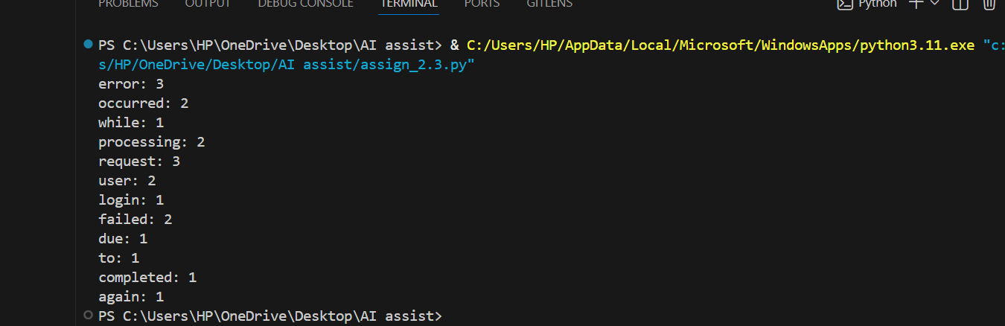
#OUTPUT

ANALYSIS
This task shows how Python can process text files to count word occurrences. It helps in understanding file handling and dictionary usage. Such programs are useful in log analysis and text analytics.
Task 2: File Operations Using Cursor AI
#PROMPT
Generate a Python program to create a text file, write sample text into it, then read the file and display its contents on the screen. Keep the code simple and beginner-friendly.
#CODE
with open("demo.txt", "w", encoding="utf-8") as file:
file.write("This is a sample text file.\n")
file.write("File operations are performed using Python.\n")
file.write("Cursor AI helped generate this code.\n")

# Read and display the file content
with open("demo.txt", "r", encoding="utf-8") as file:
content = file.read()
print("File Content:\n")
print(content)
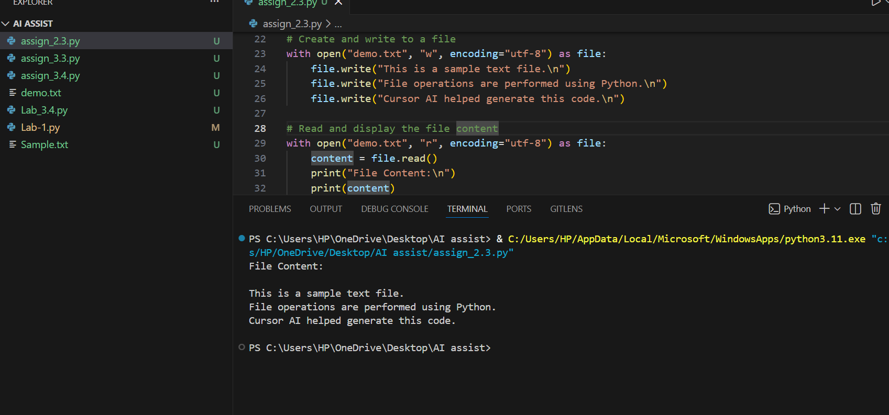
#OUTPUT
ANALYSIS
This task demonstrates basic file operations like creating, writing, and reading a text file. It helps in learning how data can be stored and retrieved from files. File operations are essential for automation tasks.
Task 3: CSV Data Analysis
#PROMPT
Use Gemini to generate Python code in Google Collab that reads a CSV file using pandas and calculates the mean, minimum, and maximum values of a column. Also explain how the code works.
#CODE
import pandas as pd

# Create sample data
data = {
"value": [10, 20, 30, 40, 50]
}

# Convert to DataFrame
df = pd.DataFrame(data)

# Save as CSV file
df.to_csv("data.csv", index=False)

# Read the CSV file
read_data = pd.read_csv("data.csv")

# Calculate statistics
print("Mean:", read_data["value"].mean())
print("Minimum:", read_data["value"].min())
print("Maximum:", read_data["value"].max())
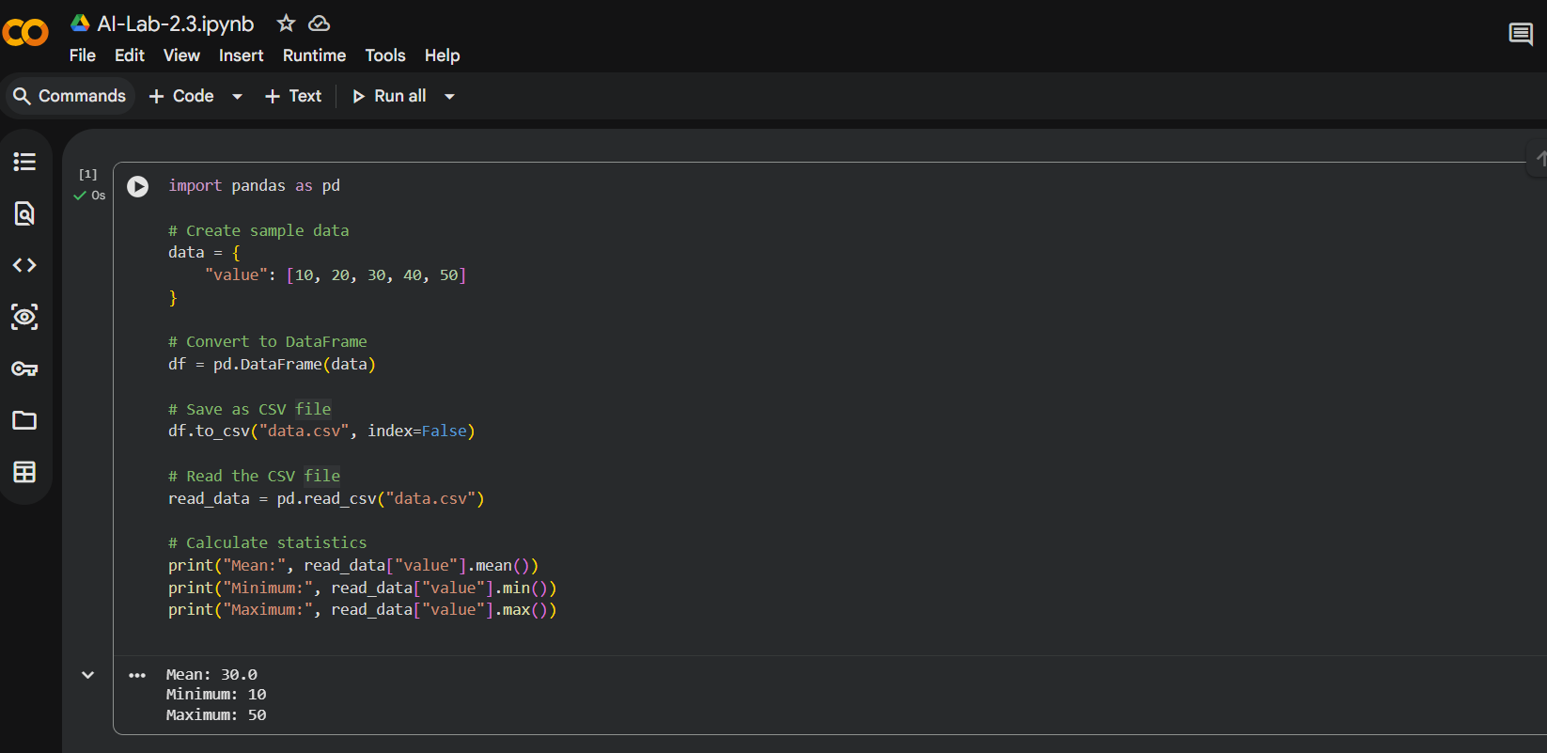
#OUTPUT
ANALYSIS
This task explains how structured data in CSV format can be analyzed using Python. By calculating mean, minimum, and maximum values, we understand basic data analysis concepts. It is useful in data science and real-world datasets.
Task 4: Sorting Lists – Manual vs Built-in
#PROMPT
Use Gemini to generate Python code for bubble sort and Python’s built-in sort () method. Compare both approaches in terms of simplicity and efficiency.
#CODE
#1. Bubble Sort (Manual Implementation)
def bubble_sort(arr):
n = len(arr)
for i in range(n):
for j in range(0, n - i - 1):
if arr[j] > arr[j + 1]:
arr[j], arr[j + 1] = arr[j + 1], arr[j]
return arr

numbers = [5, 2, 9, 1, 5, 6]
print("Bubble Sort Result:", bubble_sort(numbers))
#2. Python Built-in sort() Method
numbers = [5, 2, 9, 1, 5, 6]
numbers.sort()
print("Built-in Sort Result:", numbers)
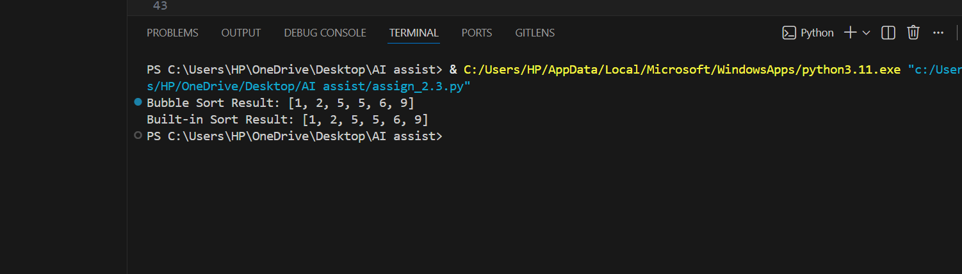
#OUTPUT

COMPARISON
Bubble Sort is a simple, manual sorting algorithm that repeatedly swaps adjacent elements. It is easy to understand but inefficient for large lists.
Python’s built-in sort () is highly optimized, faster, and recommended for real-world applications.
Bubble sort is mainly used for learning purposes, while built-in sorting is used in practical programs.
ANALYSIS
This task compares a manual sorting algorithm with Python’s built-in sort method. It highlights that built-in functions are faster and more efficient. Manual sorting helps in learning algorithm logic, while built-in sorting is preferred in practice.

